Отчет по практической работе №2.

Подготовил Порядин Андрей ПР-31.

Activity_sign_in.xml

<?xml version="1.0" encoding="utf-8"?>  
<ScrollView xmlns:android="http://schemas.android.com/apk/res/android"  
 android:orientation="vertical"  
 android:layout_width="match_parent"  
 android:layout_height="match_parent"  
 android:background="@color/gray"  
 xmlns:tools="http://schemas.android.com/tools"  
 tools:context=".SignInActivity">  
  
 <LinearLayout  
 android:layout_width="match_parent"  
 android:layout_height="match_parent"  
 android:orientation="vertical"  
 >  
  
 <ImageView  
 android:layout_marginTop="30dp"  
 android:layout_width="150dp"  
 android:layout_height="50dp"  
 android:layout_gravity="center"  
 android:src="@drawable/text">  
  
 </ImageView>  
  
 <TextView  
  
 android:layout_gravity="center"  
 android:layout_marginRight="50dp"  
 android:text="E-mail"  
 android:textColor="@color/textColor"  
 android:layout_width="wrap_content"  
 android:layout_height="wrap_content">  
  
 </TextView>  
  
 <EditText  
 android:backgroundTint="@color/bluebutcolor"  
 android:layout_gravity="center"  
 android:id="@+id/email"  
 android:layout_width="145dp"  
 android:layout_height="wrap_content"  
 android:hint="you@example.com"  
 android:textSize="10dp">  
  
 </EditText>  
  
 <TextView  
  
 android:layout_gravity="center"  
 android:layout_marginRight="45dp"  
 android:text="Пароль"  
 android:textColor="@color/textColor"  
 android:layout_width="wrap_content"  
 android:layout_height="wrap_content">  
  
 </TextView>  
  
 <EditText  
 android:backgroundTint="@color/bluebutcolor"  
 android:layout_gravity="center"  
 android:id="@+id/password"  
 android:layout_width="145dp"  
 android:layout_height="wrap_content"  
 android:hint="Ваш пароль"  
 android:textSize="10dp"  
 >  
  
 </EditText>  
  
 <Button  
 android:onClick="Enter"  
 android:layout_width="match_parent"  
 android:layout_height="50dp"  
 android:background="@color/bluebutcolor"  
 android:text="Войти"  
 android:textColor="@color/white"  
 android:textStyle="bold"  
 android:textAllCaps="false">  
  
 </Button>  
  
 </LinearLayout>  
  
</ScrollView>

Kt.

private lateinit var *email*:EditText  
 private lateinit var *password* :EditText  
class SignInActivity : ComponentActivity() {  
 override fun onCreate(savedInstanceState: Bundle?) {  
 super.onCreate(savedInstanceState)  
 setContentView(R.layout.*activity_sign_in*)  
 *email* = findViewById(R.id.*email*)  
 *password* = findViewById(R.id.*password*)  
 }  
  
 fun Enter(view: View) {  
  
  
 if (*email*.length() > 1 && *password*.length() > 1) {  
 val intent = Intent(this, MainActivity::class.*java*)  
 startActivity(intent)  
 }  
 }  
  
  
  
 }

ActivityMain.xml

<?xml version="1.0" encoding="utf-8"?>  
 <androidx.wear.widget.BoxInsetLayout xmlns:android="http://schemas.android.com/apk/res/android"  
 android:layout_width="match_parent"  
 android:layout_height="match_parent"  
 android:background="@color/gray"  
 xmlns:tools="http://schemas.android.com/tools"  
 tools:context=".MainActivity"  
 android:columnCount="3">  
  
 <LinearLayout  
 android:onClick="obs_click"  
 android:layout_marginLeft="15dp"  
 android:layout_marginTop="15dp"  
 android:orientation="vertical"  
 android:layout_width="wrap_content"  
 android:layout_height="wrap_content">  
  
 <ImageView  
 android:layout_gravity="center"  
 android:layout_width="50dp"  
 android:layout_height="50dp"  
 android:src="@drawable/firstround">  
  
 </ImageView>  
  
 <TextView  
 android:textColor="@color/white"  
 android:textSize="12dp"  
 android:layout_width="wrap_content"  
 android:layout_height="wrap_content"  
 android:text="Обсуждения">  
  
  
 </TextView>  
  
 </LinearLayout>  
  
 <LinearLayout  
 android:onClick="obs_click"  
 android:layout_marginTop="15dp"  
 android:layout_marginLeft="90dp"  
 android:orientation="vertical"  
 android:layout_width="wrap_content"  
 android:layout_height="wrap_content">  
  
 <ImageView  
 android:layout_gravity="center"  
 android:layout_width="50dp"  
 android:layout_height="50dp"  
 android:src="@drawable/secround">  
  
 </ImageView>  
  
 <TextView  
 android:textSize="12dp"  
 android:layout_width="wrap_content"  
 android:layout_height="wrap_content"  
 android:text="Обсуждения"  
 android:textColor="@color/white"  
 android:textAlignment="textStart">  
  
  
 </TextView>  
  
 </LinearLayout>  
  
 <LinearLayout  
 android:onClick="izbr_click"  
 android:layout_marginLeft="15dp"  
 android:layout_marginTop="100dp"  
 android:orientation="vertical"  
 android:layout_width="wrap_content"  
 android:layout_height="wrap_content">  
  
 <ImageView  
 android:layout_gravity="center"  
 android:layout_width="50dp"  
 android:layout_height="50dp"  
 android:src="@drawable/thirdround">  
  
 </ImageView>  
  
 <TextView  
 android:textSize="12dp"  
 android:textColor="@color/white"  
 android:layout_width="wrap_content"  
 android:layout_height="wrap_content"  
 android:text="Избранное">  
  
  
 </TextView>  
  
 </LinearLayout>  
  
  
  
</androidx.wear.widget.BoxInsetLayout>

Kt:

class MainActivity : ComponentActivity() {  
 override fun onCreate(savedInstanceState: Bundle?) {  
 super.onCreate(savedInstanceState)  
 setContentView(R.layout.*activity_main*)  
 }  
  
  
  
 fun obs_click(view: View) {  
 val intent = Intent(this,ChatListScreen::class.*java*)  
 startActivity(intent)  
 }  
  
 fun izbr_click(view: View) {  
 val intent = Intent(this,ResultActivity::class.*java*)  
 startActivity(intent)  
 }  
}

ActivityChatListScreen.xml

<?xml version="1.0" encoding="utf-8"?>  
<ScrollView xmlns:android="http://schemas.android.com/apk/res/android"  
 xmlns:app="http://schemas.android.com/apk/res-auto"  
 xmlns:tools="http://schemas.android.com/tools"  
 android:layout_width="match_parent"  
 android:layout_height="match_parent"  
 tools:context=".ChatListScreen">  
  
  
  
 <LinearLayout  
 android:orientation="vertical"  
 android:layout_width="match_parent"  
 android:layout_height="wrap_content">  
  
 <TextView  
 android:text="Обсуждения"  
 android:layout_marginLeft="70dp"  
 android:layout_marginTop="20dp"  
 android:textColor="@color/bluebutcolor"  
 android:textSize="14dp"  
 android:textStyle="bold"  
 android:layout_width="wrap_content"  
 android:layout_height="wrap_content">  
 </TextView>  
  
 <LinearLayout  
 android:layout_width="match_parent"  
 android:layout_height="50dp">  
  
 <TextView  
 android:textColor="@color/white"  
 android:layout_marginLeft="30dp"  
 android:layout_gravity="center"  
 android:text="Lucifer"  
 android:layout_width="wrap_content"  
 android:layout_height="wrap_content">  
 </TextView>  
 </LinearLayout>  
  
 <LinearLayout  
  
 android:layout_width="match_parent"  
 android:layout_height="50dp">  
  
 <TextView  
 android:textColor="@color/white"  
 android:layout_marginLeft="30dp"  
 android:layout_gravity="center"  
 android:text="The Witcher "  
 android:layout_width="wrap_content"  
 android:layout_height="wrap_content">  
 </TextView>  
 </LinearLayout>  
  
 <LinearLayout  
  
 android:layout_width="match_parent"  
 android:layout_height="50dp">  
  
 <TextView  
 android:textColor="@color/white"  
 android:layout_marginLeft="30dp"  
 android:layout_gravity="center"  
 android:text="LOST"  
 android:layout_width="wrap_content"  
 android:layout_height="wrap_content">  
 </TextView>  
 </LinearLayout>  
  
 <LinearLayout  
 android:layout_width="match_parent"  
 android:layout_height="50dp">  
  
 <TextView  
 android:textColor="@color/white"  
 android:layout_marginLeft="30dp"  
 android:layout_gravity="center"  
 android:text="The Magicans"  
 android:layout_width="wrap_content"  
 android:layout_height="wrap_content">  
 </TextView>  
 </LinearLayout>  
  
  
 </LinearLayout>  
  
  
  
</ScrollView>

ActivityResult.xml

<?xml version="1.0" encoding="utf-8"?>  
<ScrollView xmlns:android="http://schemas.android.com/apk/res/android"  
 android:layout_width="match_parent"  
 android:background="@color/gray"  
 android:layout_height="match_parent"  
 xmlns:tools="http://schemas.android.com/tools"  
 tools:context=".ResultActivity"  
 tools:deviceIds="wear">  
  
 <LinearLayout  
 android:layout_width="match_parent"  
 android:layout_height="wrap_content"  
 android:orientation="vertical">  
  
  
 <TextView  
 android:text="Новое"  
 android:layout_marginLeft="70dp"  
 android:layout_marginTop="20dp"  
 android:textSize="14dp"  
 android:textStyle="bold"  
 android:textColor="@color/bluebutcolor"  
 android:layout_width="wrap_content"  
 android:layout_height="wrap_content">  
  
  
 </TextView>  
  
  
  
 <RelativeLayout  
 android:layout_marginTop="10dp"  
 android:layout_width="match_parent"  
 android:layout_height="wrap_content">  
  
  
  
  
 <ImageView  
 android:id="@+id/imageView"  
 android:src="@drawable/img_wither"  
 android:layout_width="match_parent"  
 android:layout_height="match_parent"/>  
  
 <ImageView  
 android:src="@drawable/uil_play"  
 android:layout_centerInParent="true"  
 android:layout_width="wrap_content"  
 android:layout_height="wrap_content"/>  
  
 <TextView  
 android:layout_alignParentBottom="true"  
 android:layout_centerHorizontal="true"  
 android:layout_alignParentLeft="true"  
 android:layout_marginLeft="20dp"  
  
 android:text="Witcher"  
 android:textColor="@color/white"  
 android:textStyle="bold"  
 android:textSize="16dp"  
 android:layout_width="wrap_content"  
 android:layout_height="wrap_content"/>  
  
 </RelativeLayout>  
  
 <RelativeLayout  
 android:layout_marginTop="10dp"  
 android:layout_width="match_parent"  
 android:layout_height="wrap_content">  
  
  
  
  
 <ImageView  
  
 android:src="@drawable/img_jess"  
 android:layout_width="match_parent"  
 android:layout_height="match_parent"/>  
  
 <ImageView  
 android:src="@drawable/uil_play"  
 android:layout_centerInParent="true"  
 android:layout_width="wrap_content"  
 android:layout_height="wrap_content"/>  
  
 <TextView  
 android:layout_alignParentBottom="true"  
 android:layout_centerHorizontal="true"  
 android:layout_alignParentLeft="true"  
 android:layout_marginLeft="20dp"  
 android:text="Jessica Jones"  
 android:textColor="@color/white"  
 android:textStyle="bold"  
 android:textSize="16dp"  
 android:layout_width="wrap_content"  
 android:layout_height="wrap_content"/>  
  
 </RelativeLayout>  
  
 <RelativeLayout  
 android:layout_marginTop="10dp"  
 android:layout_width="match_parent"  
 android:layout_height="wrap_content">  
  
  
  
  
 <ImageView  
  
 android:src="@drawable/img_third"  
 android:layout_width="match_parent"  
 android:layout_height="match_parent"/>  
  
 <ImageView  
 android:src="@drawable/uil_play"  
 android:layout_centerInParent="true"  
 android:layout_width="wrap_content"  
 android:layout_height="wrap_content"/>  
  
 <TextView  
 android:layout_alignParentBottom="true"  
 android:layout_centerHorizontal="true"  
 android:layout_alignParentLeft="true"  
 android:layout_marginLeft="20dp"  
 android:text="Magicians"  
 android:textColor="@color/white"  
 android:textStyle="bold"  
 android:textSize="16dp"  
 android:layout_width="wrap_content"  
 android:layout_height="wrap_content"/>  
  
 </RelativeLayout>  
  
 </LinearLayout>  
  
</ScrollView>

Скриншоты программы :

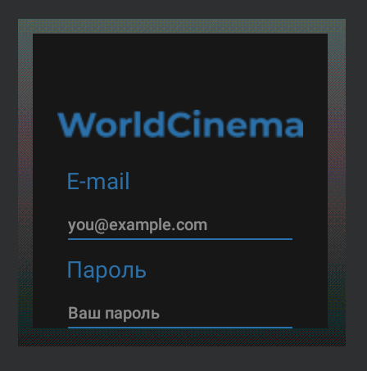

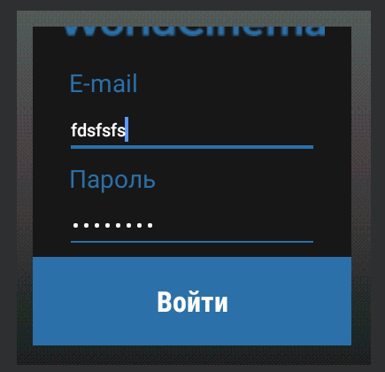

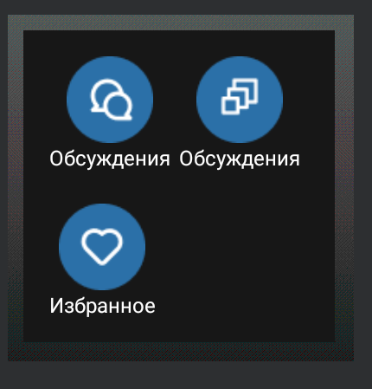

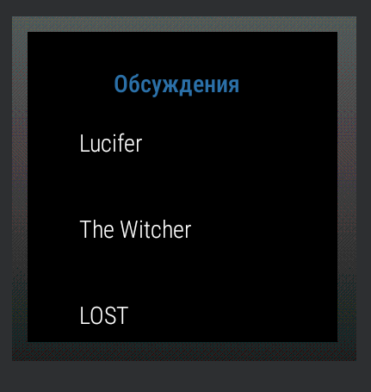

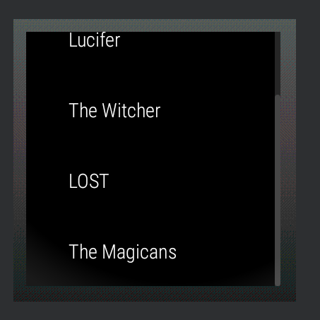

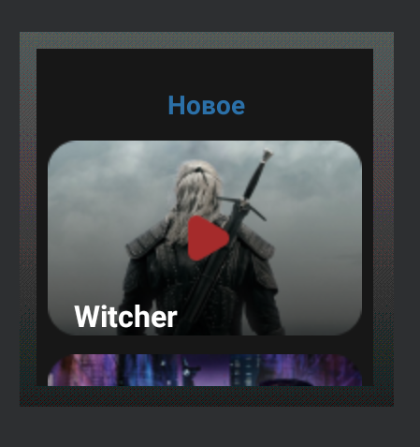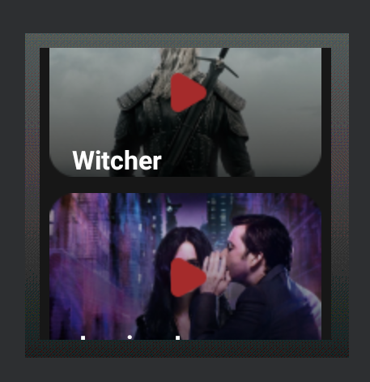

Вывод: Была разработана программа для WorldCinema.